Name:______________________________________________
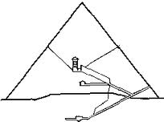

The Great Pyramid - Word Bank
Grand Gallery | Northern Air Shaft
King’s Chamber | Descending Passage
Underground Chamber | Southern Air Shaft
Queen’s Chamber

